Native American Day
Presbyterian Church, USA

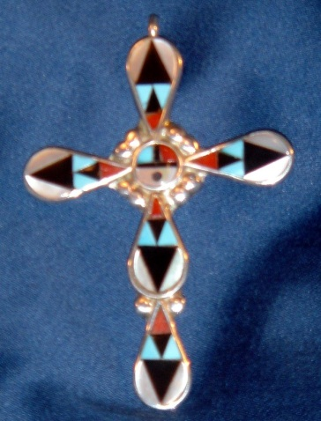

Resources for Celebrating the Gifts of
Native Americans to the Church

Native American Day is celebrated in the Presbyterian Church, USA on September 22nd or 23rd (Fall Equinox).

Since 1994, Native American Day appears on the Presbyterian Calendar as the day to recognize and celebrate the contributions of Native Americans/American Indians to the life of the church and community. The date of September 22nd or 23rd was selected and established the date for Native American Day. Ironically, Fall Equinox is noted on one or the other date. The Fall Equinox has marked “harvest time” for many Native American tribes for centuries and is a time of celebration and preparation for winter.

Native American Day 2014 will be celebrated within the Presbyterian Church, USA on September 23rd with a worship service being held at the Presbyterian Center in Louisville, Kentucky. Members of the Advisory Council for Native American Congregational Support will be meeting during that week and will be participating in that service of worship.

“Does the Presbyterian Church (U.S.A.) do ‘mission work’ with Native Americans?” This is a frequent question asked of the Office of Native American Congregational Support. The answer is, “Yes, Native Americans have an active presence and identity with the Presbyterian Church (U.S.A.).” Often the genesis of this relationship was through mission outreach of our predecessor denominations. Missionary work with Native Americans began in 1641 with the establishment of a mission among the Shinnecock tribe on Long Island, NY. The congregation still exists today and is led by a Shinnecock Presbyterian minister.

Native American churches are located from the Shinnecock on Long Island to Neah Bay, Washington on the Makah Indian reservation, from the Alabama-Coushatta in Livingston, Texas to the Inupiaq at Point Barrow, Alaska. There is active involvement in ministry and support for these local churches and fellowships in twenty presbyteries within seven synods of the PCUSA. Two presbyteries, Dakota (non-geographic) and Grand Canyon each identify twenty-one churches and chapels within their bounds. Synod of Alaska-Northwest has twenty-six Native congregations in their bounds.

The ninety-five Native American congregations and chapels are located on reservations, in rural areas and two urban congregations. There are twenty-one presbyteries and seven synods which have Native American constituents in them. Some of the churches are isolated due to location. Anchor Presbyterian Church, Anchorage, AL. Yukon Presbytery was constituted in January of 2008. It is the first church in recent times in an urban area with a Native American focus. Of all the churches, Central Presbyterian Church located in Phoenix, Arizona is the other urban church.

Celebration of Native American Day gives recognition to the presence of Native Americans in our society and church today. A directory of the churches and chapels has been updated for 2014 and is now available.

A shortage of ordained Native American clergy exists. The churches are dependent upon lay leadership because many cannot meet the presbytery minimum salary necessary to pay a full-time pastor. Most of these congregations are comprised of Native people who earn low incomes so consequently do not have the resources to sustain full-time ordained ministries. The loss of national and mid-governing body mission funding has contributed to an already acute leadership crisis in these churches.

Connections and partnerships between non-native and native churches around mission projects have been ongoing for several years and mutually beneficial. Groups have worked together in the local community, help with church building needs and conduct Vacation Bible School. A better understanding between both cultures has developed as well.

Diversity exists in the languages, cultures, and tribal governments but a common history is their faith journey. Native American Presbyterians love to tell the story and welcome opportunities to do so.

DID YOU KNOW?

- As of May 2013, there are 566 federally recognized tribes located on reservations, in rural areas on allotment lands and in the cities.
- Concentration of Native Americans is larger in cities versus some of the reservations.
- Allotment land: Break up of Indian territories resulted in land being distributed to individuals (180 acres).
- Relocation: Government program which sought to relocate Native people to urban areas of the country in the 1950’s and early 60’s to assist families with employment and education for single adults. Some stayed and others returned to their homeland. Often they were given bus fare to the city and a small stipend then were expected to support themselves afterward. Many were without skills to obtain jobs.
- As of 2011, there were 460 gambling operations run by 240 tribes. Many of the Pacts which created the gaming operations require tribes to give-back to surrounding municipalities a percentage of their earnings annually. Since there are 326 tribes who do not have gaming operations on their reservations, the idea that “all Indian tribes have casinos” is false.

It will be my pleasure to answer any questions you may have or discuss ideas you may have planning your celebration of Native American Day.

“May the warm winds of heaven blow softly upon you
and the Creator make sunrise in your hearts.”
(Cherokee Prayer)

Rev. Irvin Porter, Associate
Native American Congregational Support
Racial Ethnic/Women’s Ministry and Presbyterian Women
(502) 569-5331 or (888)728-7228 Ext. 5331
Irvin.porter@pcusa.org

WEB PAGE: http://www.presbyterianmission.org/ministries/nativeamerican/about-us/
FACEBOOK: https://www.facebook.com/pages/Native-American-Ministries-PCUSA/232067750278099
A speech presented by Donna Kuyiyesva, Treasurer of the Native American Consulting Committee, at the Multicultural Conference in Fort Worth, TX on August 1, 2014:

Opening the Container of Wisdom:
Native American Resurgence within the Church

The Presbyterian Church’s presence among the Native American people of this continent began in the mid 1700’s when Rev. Ezeriah Horton was sent to work among the Shinnecock people of Long Island, NY.

Since then, Native American Presbyterians can be found in scattered locations across the North American continent. Their major locations form an enormous triangle that starts at the eastern tip of New York’s Long Island with a Shinnecock congregation and stretches to Pima churches along Arizona’s Gila River, then to Eskimo parishes at Point Barrow and other places in northwestern Alaska.

The Presbyterian Church has left its impact among four diverse tribes; The Dakota Sioux of South Dakota, the Choctaw of southeastern Oklahoma, the Pima of southern Arizona, and the Nez Perce of north-central Idaho. It is among these tribes where the strength of Native American Presbyterianism is felt the strongest.

Native Americans within the Church number at least twenty tribes as well as Eskimos and Aleuts. They worship in some 95 churches and chapels with an estimated Native leadership of about twenty people. And the number grows even less with each passing year.

Native people are a people with hope. We have experienced much that is both good and bad. But we still hope. We are a resilient people. Always adapting new ways and making them uniquely our own.

We have developed and maintained our own religious identities with a variety of considerations in mind.

- Like native traditions, Christian institutions can mediate social power and material resources and provide avenues for the development and recognition of religious leadership.

- Like native traditions, Christian worship can facilitate community reconciliation and allow for the fulfillment of ceremonial obligations.

- Like native traditions, Christian teachings can articulate beliefs and values that provide direction in daily life and in overcoming personal struggles, and that form the basis for political action.

- Like native traditions, Christian spiritual practices can cultivate meaning and purpose through religious devotion, offering a possible alternative to materialism, and can challenge people to a life of responsibility and service.

Native people who choose to identify themselves with Christian institutions, worship, teachings, or spiritual practices do so while bearing in mind the community circumstances, family traditions, and personal experiences that define their lives.

Furthermore, many Native Christians accomplish this identification without abandoning or rejecting Native traditions.

This runs contrary to the practices of our parents or grandparents who were taught by some missionaries that our culture was evil, wicked and something not worth preserving.

The Spirit of God is apparent and at work like never before to overcome barriers. But many obstacles remain. The resurgence of Native American religion has successfully recruited many Native people to either abandon or reject Christianity as a “white man’s religion.”

Distrust prevails when Indians see the very government bureau managing Indian Affairs is managed, itself, by the Department of the Interior – an agency that oversees public lands and wildlife, not people.

In the nineteenth and even early twentieth century’s Native clergy saw in Christianity a universal message of hope and power. Educated and trained within their own communities, and often in their own languages, Native American ministers shaped Indian Presbyterianism even as Native society justified their leadership.

Not all Native tribes have casinos. Not all Native people are anti-Christian. Not all Native people have forgiven white society for the dealings of the past.

Today, you have opened the Container of Wisdom. You have looked through the eyes of my people and have seen God in a new way. Change your perspective and listen with the ears of other cultures to God, our Creator. When you do so, you will find out that we really aren’t so different after all.

Native American Presbyterians in the last century created and handed down to their children and grandchildren, a distinctly Native Christian tradition that still informs our identity. It’s a proud legacy. We have created our own traditions and have once again adapted making it our own.

“May the warm winds of heaven blow softly upon you and the Creator make sunrise in your hearts.”

Amen.
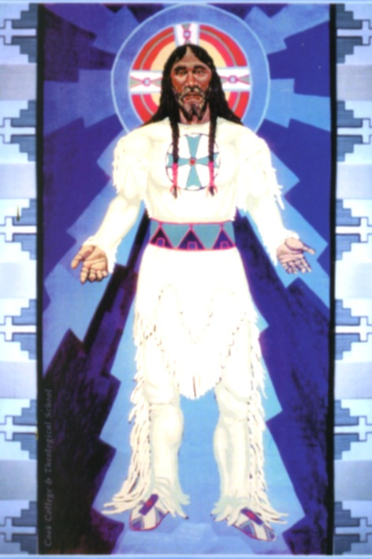

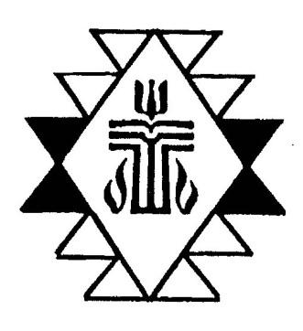

Resources on Native Americans
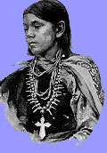

Bibliography

- Treat, James (ed.). Native and Christian: Indigenous Voices on Religious Identity in the United States and Canada, Routledge, NY, 1996.

- Kidwell, Clara Sue; Noley, Homer; Tinker, George E. A Native American Theology, Orbis Books, NY, 2001.

- Bopp, Judie; Bopp, Michael; Brown, Lee; Lane, Phil Jr. The Sacred Tree: Reflections on Native American Spirituality, Lotus Press, Twin Lakes, WI., 1984.

- Bean, Tom and Lamb, Susan. Holy Week in WhiteRiver, Tau Publishing, Phoenix, AZ., 2008.

- Trafzer, Clifford E., Keller, Jean A., and Sisquoc, Lorene (eds.). Boarding School Blues: Revisiting American Indian Educational Experiences, University of Nebraska Press, Lincoln, NE. 2006.

- Coleman, Michael. Presbyterian Missionary Attitudes toward American Indians, 1837-1893, University Press of Mississippi, Jackson, MS. 1985.

- Hofstra, Marilyn M., Voices: Native American Hymns and Worship Resources, Discipleship Resources, 1992.

- Gabriele, Edward Francis, From Many, One: Praying Our Rich and Diverse Cultural Heritage, Ave Maria Press, Inc., Notre Dame, IN, 1995.

- Tirabassi, Maren C. & Eddy, Kathy Wonson, Gifts of Many Cultures: Worship Resources for the Global Community, United Church Press, Cleveland, OH., 1995

- Pima/Maricopa Elders and Deacons Assc., History of the Pima-Maricopa Presbyterian Camp Meeting: Vah-ki Presbyterian Church, Bapchule, Arizona, 2006.

- Catolster, Alyne JoAnn, Gifts from the Heart: A Resource for Small Groups – Faith Stories from Native Americans, United Methodist Church, Nashville, TN., 2000.

