IT IS A REALITY- PEOPLE ARE STARVING IN MALAWI
As reported by: Mphatso M. Nguluwe Director of LISAP (Livingstonia Synod Aids Program)
Mjedu Village, of Group Village headman Mjuma TA Mtwalo in Mzimba District, is one of the areas which was heavily affected by erratic rains. The rains fell a few times in January and stopped. People had already planted their crops in preparation to avert hunger in the coming season but rains were nowhere to be seen. Some of the people even took loans to buy farm inputs that they could repay after selling their yields but they ended up having no yield at all and loans are still outstanding. Life slowly started showing signs of problems when they saw their crop withering and finally drying up before time. Heavy thoughts lingered in peoples’ minds on how they are going to repay the loans and at the same time how they are going to survive without food. People had put hope in the government as they heard that the government was importing maize from neighboring countries but alas, this maize is nowhere to be seen.
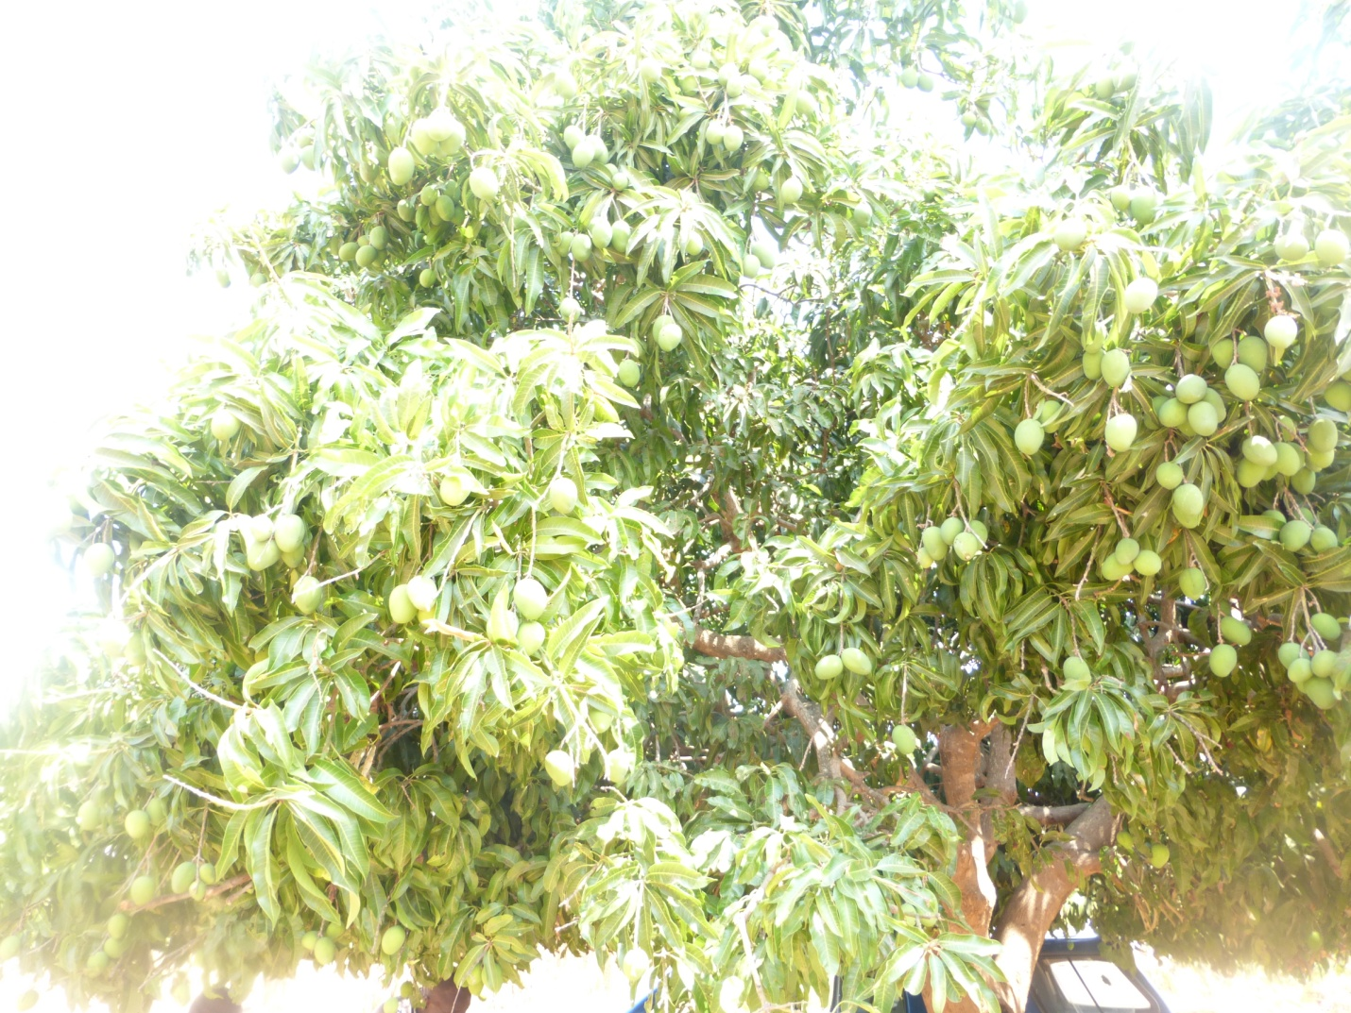
‘We spend three days or more in Rumphi grain market (ADMARC) which is about 50 kilometers away from our homes only to be told on the third day that the maize is finished before we could even buy. People are collapsing on the queues due to hunger but there is no help in sight. This time people have resorted to cooking green unripe mangoes which are not even ready for consumption but they are eating these as a meal. This as an effort to make their tummies full but it is not ideal. People are going to die because the worst months are yet to come and in those months people usually depended on ripe mangoes but when that time comes these mangoes will already be finished.. it is a sad situation, said VH Mjedu.’
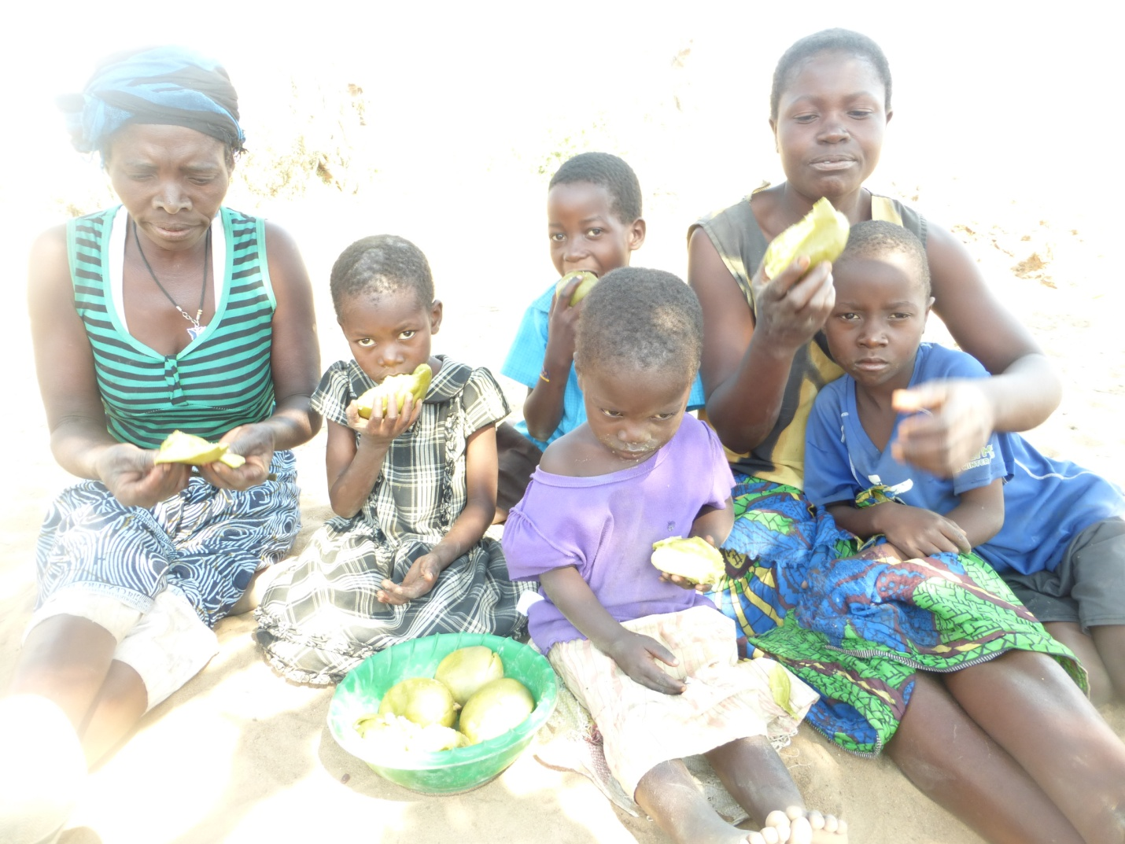
The situation described above makes me immediately think of people who are living with HIV. For them to be able to take their antiretroviral (ARV) drugs, they depend on food and if food is not available we run a risk of drug non-compliance which will lead to increased morbidity and mortality rates which are at present 130 deaths per day. At the same time we need to remember that ARVs reduce HIV transmission rates by at least 98%. So when people stop them, it means we will have high HIV incidences. Both adults and children are at a great risk but more so children.
It is estimated by the government that 2.8 million people are at risk country-wide but according to my assessment of the situation it could be more. My wish is to assist 15,000 families of children living with HIV and protect them from malnutrition as well as other illnesses and consequently death.
My last words: We need quick interventions.

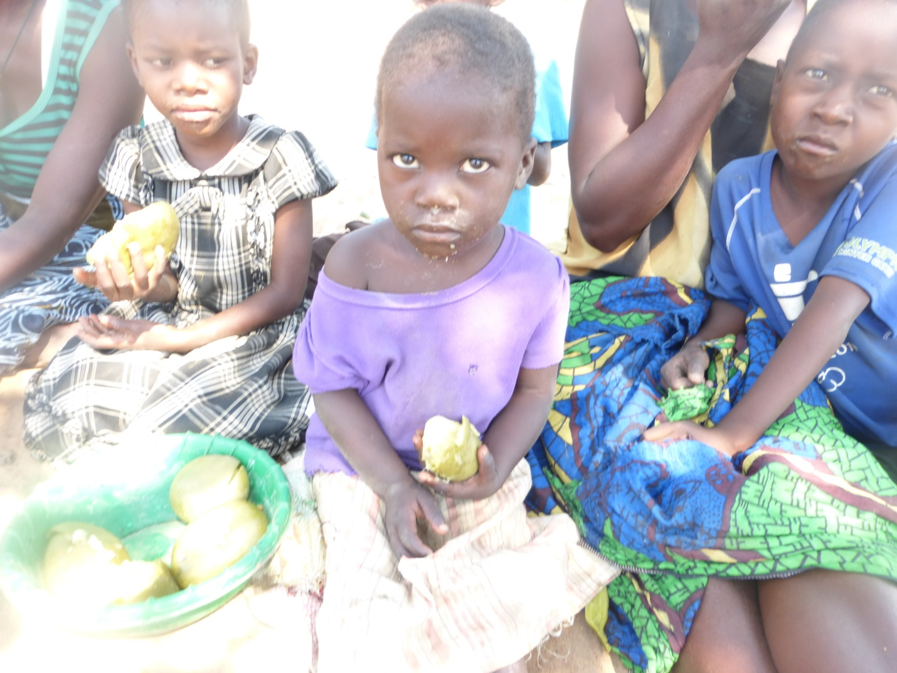
Note from Debbie Braaksma, Presbyterian World Mission Africa Coordinator: The CCAP Synod of Livingstonia Development Department is responsible for emergency response within the CCAP Synod of Livingstonia and Mr. Mabvotu Lupwayi, director of that department shared that they would “liaise with LISAP so that they are responsible for targeting and distributions and we would be responsible for logistics (procurement, transportation etc.) for the response targeting the people in question.”

